**Problem No. 1**

**Correlation Matrix:**

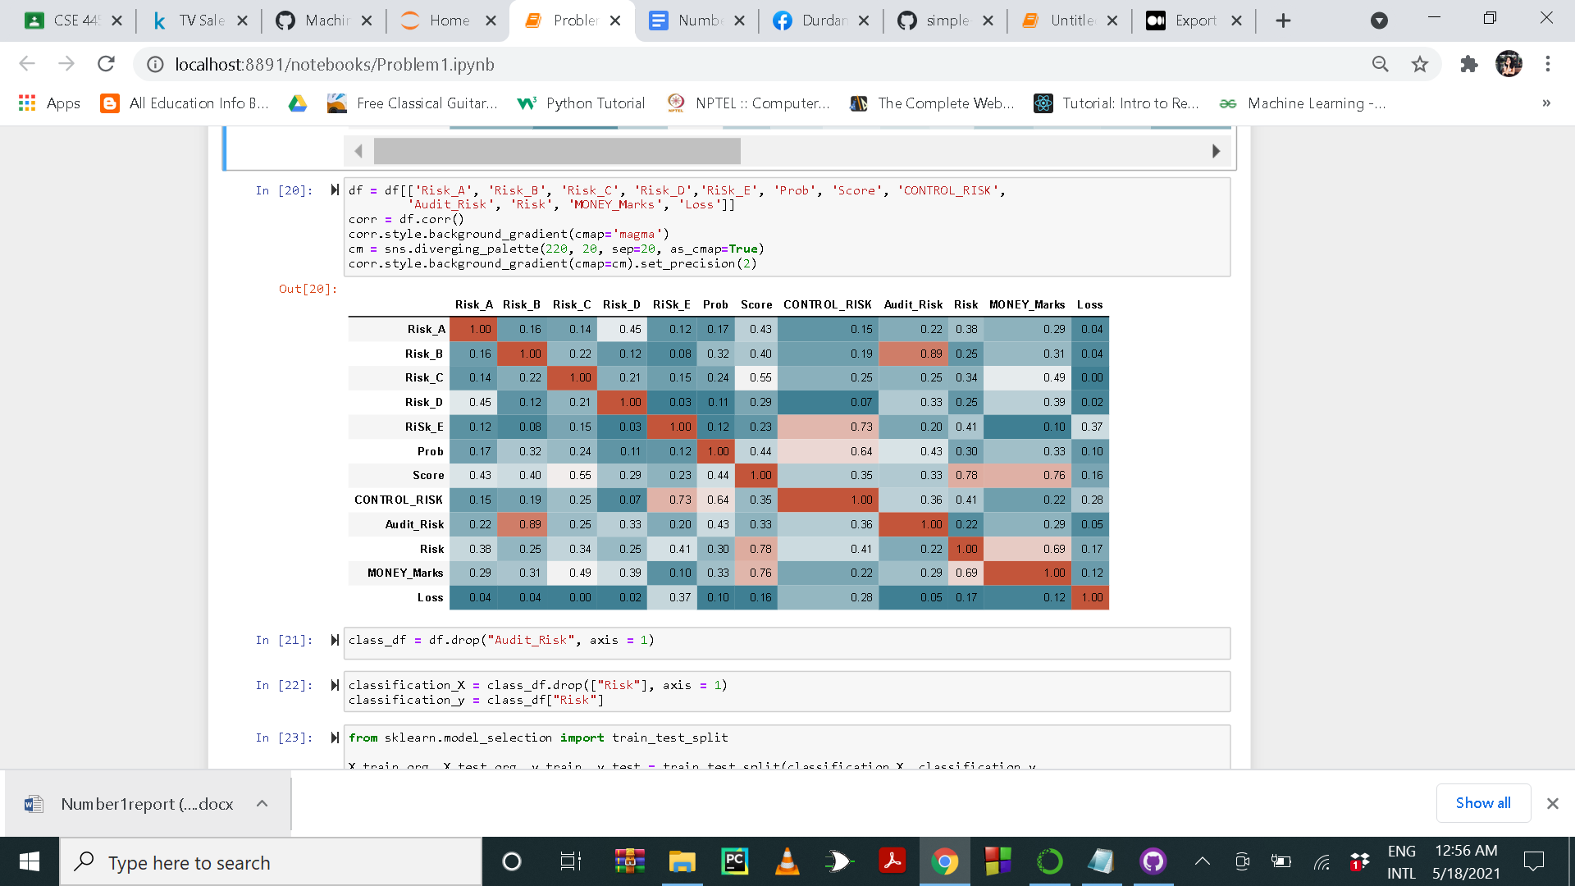

**Classifiers:**

* **Logistic Regression**Logistic regression is a method of linear classification. Logistic regression is fast and convenient, and its results are also easily interpreted. Although it’s mostly a method for binary classification, it can also be applied to multiclass problems.
* **Decision Tree Classifier**A Decision Tree is a simple representation for classification. It is a Supervised Machine Learning where the data is continuously split according to a certain parameter.
* **K-Neighbours Classifier**The k-nearest neighbors (KNN) algorithm is a supervised machine learning algorithm that can be used to solve both classification and regression problems. It is simple and easy to solve.

**Table:**

|  |  |  |
| --- | --- | --- |
| **Model Name** | **Training Score** | **Testing Score** |
| Logistic Regression | 0.952632 | 0.947368 |
| Decision Tree | 1 | 0.978947 |
| KNN | 0.987719 | 0.957895 |